#### Project Title: Passive Sonar Demonstration System

#### Requester: Tom Northardt

#### Phone/Email: (401) 846 1462/tom.northardt@mikelinc.com

#### Company: MIKEL Inc.

#### Address: 2 Corporate Pl., Suite 103

#### City: Middletown State: RI Zip Code: 02842

#### Date: 7, August, 2019

### Please note that all RFP Forms must be completed by or before August 1 of a project cycle. If you have any questions regarding the RFP process for Senior Capstone Projects, please contact the College of Engineering at 508-999-8539. Email inquiries may be sent to rlaoulache@umassd.edu

**Title:**

# Passive Sonar Demonstration Software

**Description:**

The Board of Directors of the Pacific Fleet Submarine Memorial Association, AKA Bowfin Memorial, have asked MIKEL Inc. to develop a passive sonar demonstration system for their museum. The Board of Directors would like MIKEL to develop a basic interactive broadband passive sonar system consisting of a touch-screen graphical user interface, raster data display, and two microphones. The system will allow a user to see how sonar data is typically presented in advanced sonar systems and localize, in real time, user generated acoustic sources.

**Diagrams *(optional)*:**

The diagram below describes the current concept in mind. It has four major components. 1) It has a main display area for the sonar raster data. 2) It has user controls to allow the user to select specific pre-stored sound or a user input sound. 3) It has two microphone inputs that are used to localize user input sound. 4) It has an output loud speaker for the user to hear the pre-stored sounds.

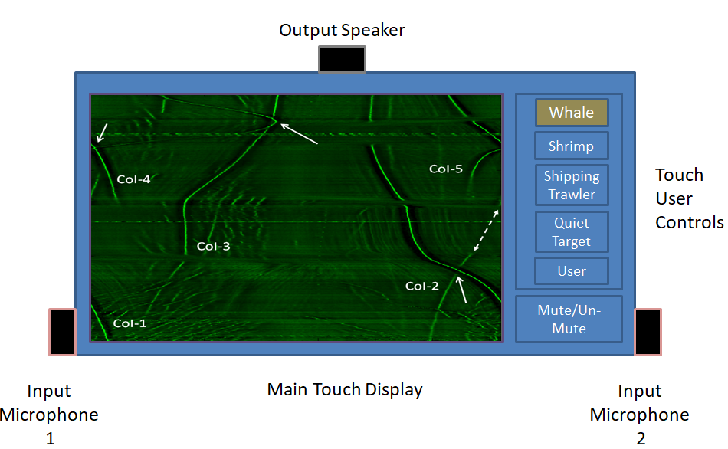

**Scope:**

This project focuses on the development of a passive sonar demonstration systems for use by those who are unfamiliar with passive broadband sonar processing.

The demonstration software system will have the hardware shown in the above figure and provide the following capabilities:

1. It will provide a user interaction through a graphical touch display
2. It will allow a user to select one of four pre-stored acoustic inputs; whale, shrimp, a shipping trawler, or a quiet target. When such is selected the user will be able to hear the pre-stored sound through the loud speaker and see the energy level of the sound reflected in the sonar raster data in the center (green gram).
3. It will allow the user to generate their own acoustic input and the system will use the two microphones to beamform in a 180 degree field and show the received energy on the display. With only a two-element acoustic array, advanced super-resolution beamforming techniques will be used to provide adequate directionality to a user-generated acoustic noise source. The user will use one of several provided continuous acoustic sources such as a drum or guitar.

**Known constraints *(if any)*:**

* Hardware (subject to change)

64bit PC

* Software (subject to change)

Python or MATLAB, Windows-based

* Interfaces (subject to change)

There should be no external interfaces

**Deliverables:**

Chief Deliverables should be the following

1. Functional description document (FDD)
2. Software source code with build and compilation instructions
3. Software executable code
4. Live demonstration

**Legal Information:**

Check below if this project involves:

IP Ownership by Sponsor (please contact rlaoulache@umassd.edu)

Non-Disclosure Agreement (please contact rlaoulache@umassd.edu)

**Project Classification:**

Select one of the classifications— Intradisciplinary1 or Interdisciplinary[1]:

Intradisciplinary *(select a single discipline)*

Bioengineering

Civil and Environmental Engineering

Computer and Information Science

Computer Engineering

Electrical Engineering

Mechanical Engineering

Physics

Interdisciplinary *(select multiple disciplines)*

Bioengineering

Civil and Environmental Engineering

Computer and Information Science

Computer Engineering

Electrical Engineering

Mechanical Engineering

Physics

**Special Instructions:**

<List specific instructions here.>

*(To be completed in September by the team that undertakes the project)*

Team Number: ­­­­________

#### Student 1: ________ ________________________________

*(Project Manager)*

Student 2: ______________________________ _________________

#### Student 3: ________________________ _________ _______

#### Student 4: _____________________ _________________

#### Student 5: ________________ ______________________

#### Faculty Advisor: ____________________________________ __

#### Project Mentor: __________________________ _____________

1. Intradisciplinary: working within a single discipline.

   Interdisciplinary: integrating knowledge and methods from different disciplines, using a real synthesis of approaches.